**Project Report**

**BUILD AN EMPLOYEE TRAVEL APPROVEL APPLICATION FOR CORPERATES**

1. **INTRODUCTION**
   1. **Overview**

This Project helps in sending the employees travel approval requests to the manager in place of emails. Travel request forms are designed to give the management to overview the intended business trip along with a cost and a strategic point of view. The fields that typically appear on a travel request form include; Employee name and contact information. Travel Approval Request App will help users quickly send a "Travel Request" through mobile using Power Apps.

**The implementation types are:**

• Stand-alone (not integrated with Concur Travel or Concur Expense)

• Integrated with Concur Travel (but not Concur Expense)

• Integrated with Concur Expense (but not Concur Travel)

• Integrated with Concur Travel and Concur Expense

Each type of implementation is addressed separately in this report.

* 1. **Purpose**

Travel takes us out of our comfort zones and inspires us to see, taste and try new things. It constantly challenges us, not only to adapt to and explore new surroundings, but also to engage with different people, to embrace adventures as they come and to share new and meaningful experiences with friends and loved ones.

so the travel approval applications can help sort out any issues during check-in at the airport or hotel and it's a simple way of helping you keep track of your travel plans. You can have these as printed copies or use one of the several Travel Planner apps or tools that you can find online.

**Benefits for the travel plane**

It makes travel more affordable. ...

You can pick your perfect destination and travel dates. ...

You can get to know your destination and decide what to do during your free time. ...

You can plan for a longer trip. ...

You can score cheaper flights. ...

You can get access to special events.

1. **Problem definition & Design thinking**
   1. **Empathy map**

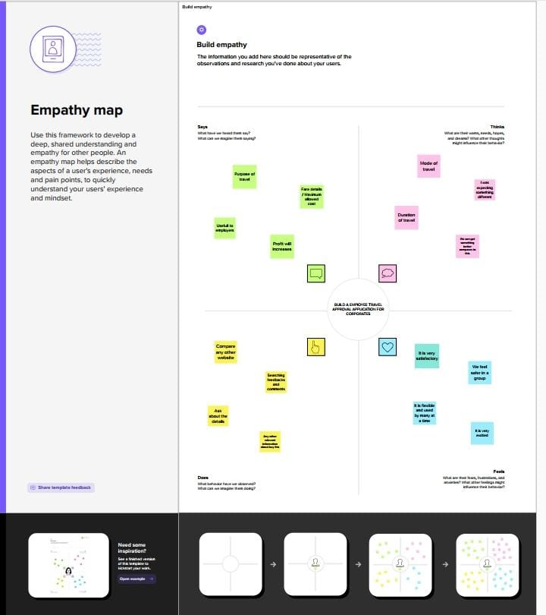

* 1. **Ideation & Brainstorming map**

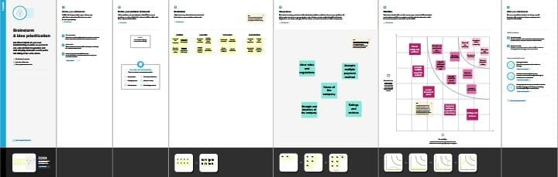

1. **Result**

During this section, the source of knowledge methods of collection, the upgradation of the prevailing system and therefore the organization structure of the system problem are showcase. It includes some methods which were utilized in order to realize the intent of the project, particular requirements for execution of the project and an extended explanation of why such methods were used for implementing the proposed system, also included may be a brief description of the current time system.

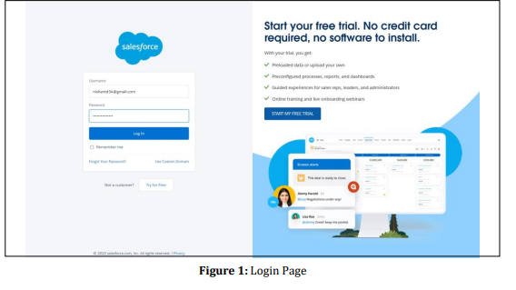

* 1. **Data model**

|  |  |
| --- | --- |
| **Object name** | **Fields in the Object** |
| Department | |  |  | | --- | --- | | **Field lable** | **Data type** | | Amount | Currency | |
| Travel approvel | |  |  | | --- | --- | | **Field lable** | **Data type** | | Travel approvel | Master-detail relationship | |
| Expense item | |  |  | | --- | --- | | **Field lable** | **Data type** | | Expense item | Roll_up summary | |

* 1. **Screenshots of my project activities**

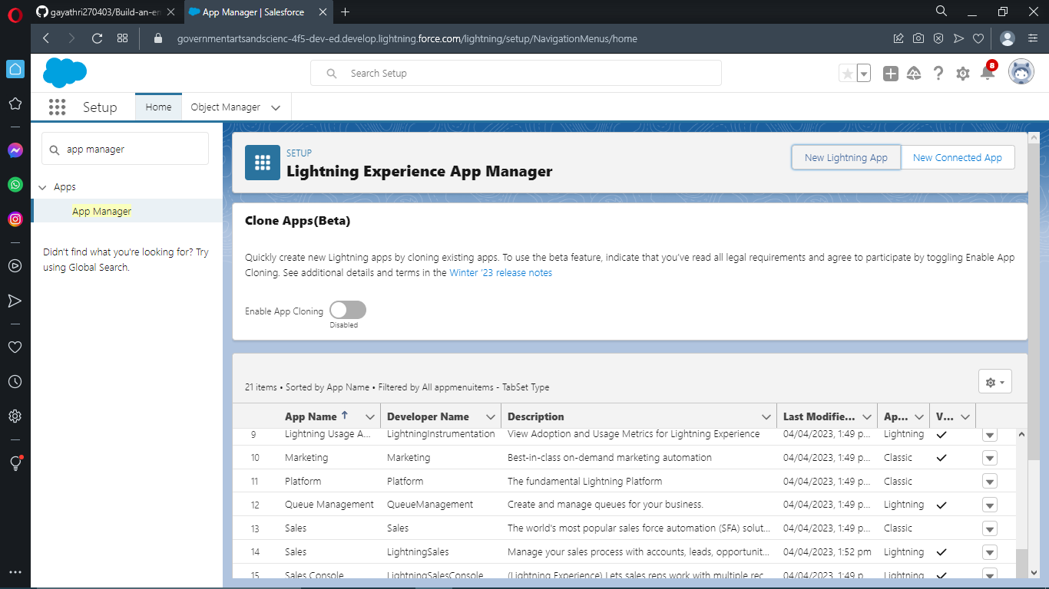

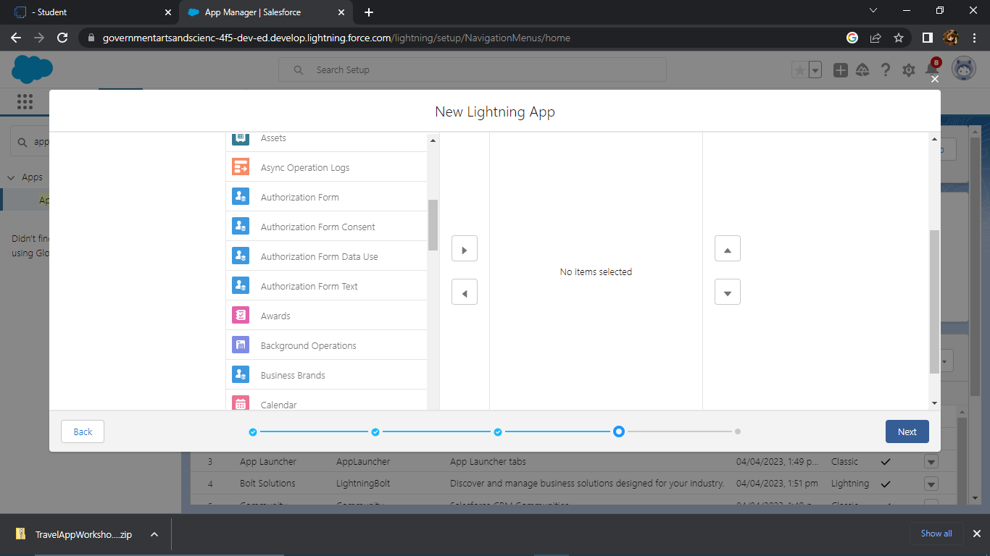

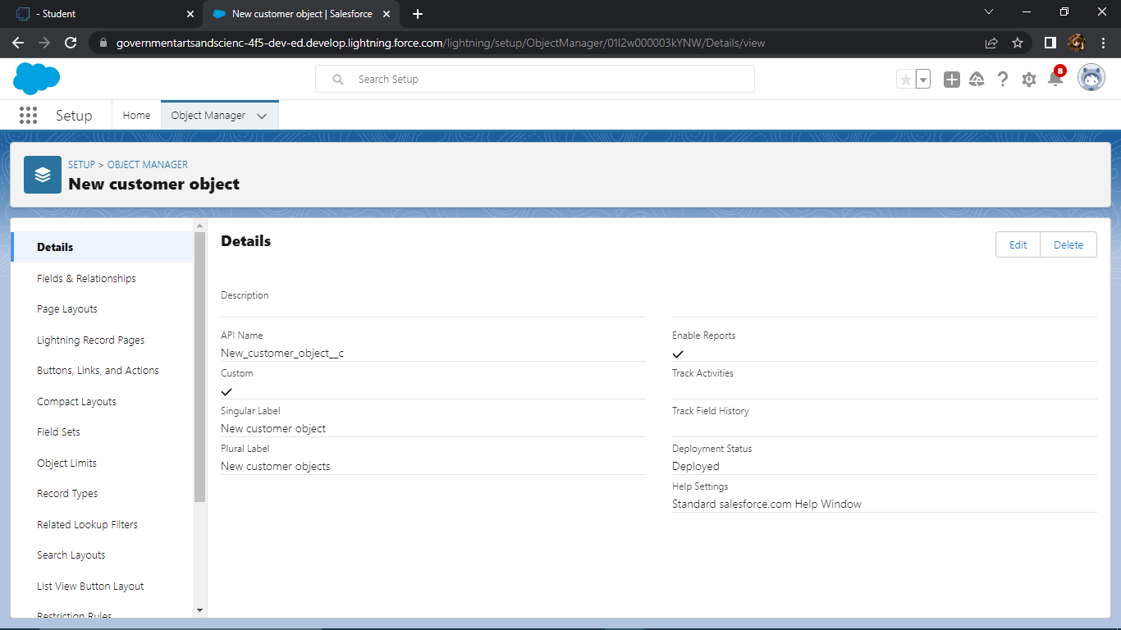

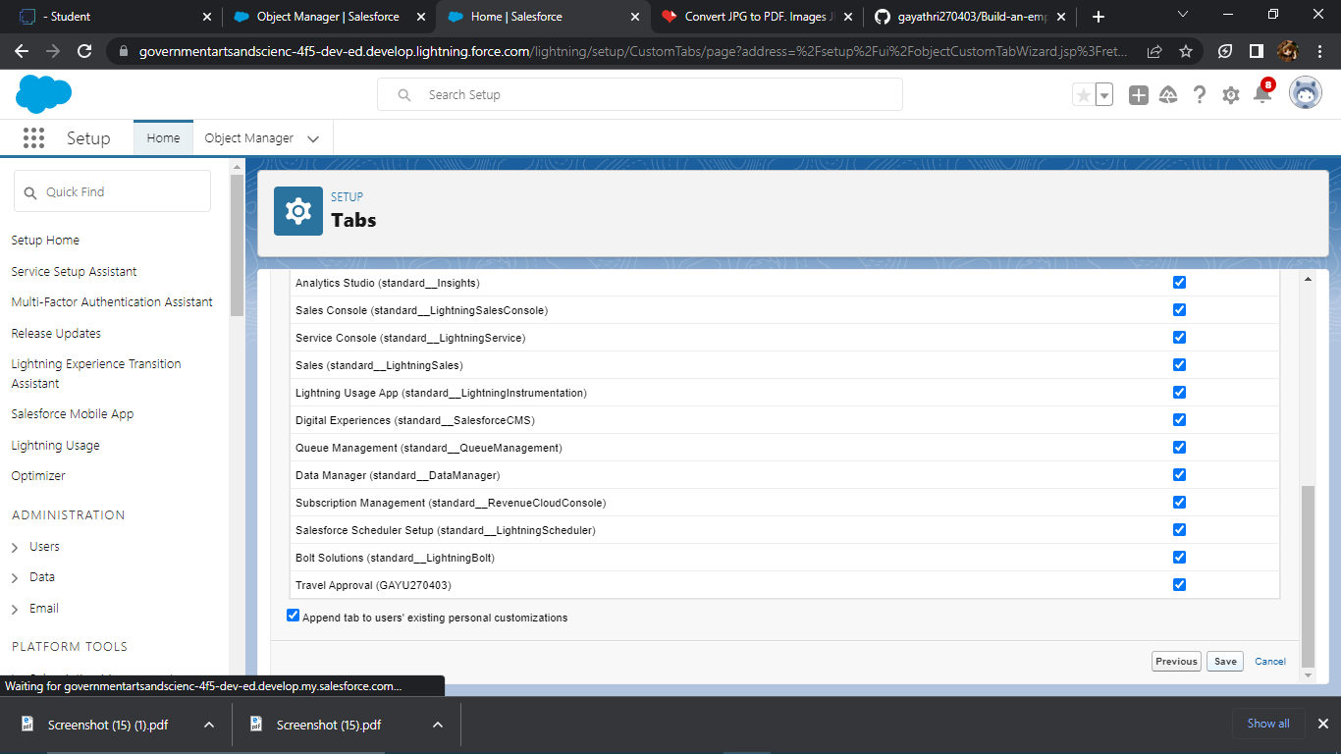

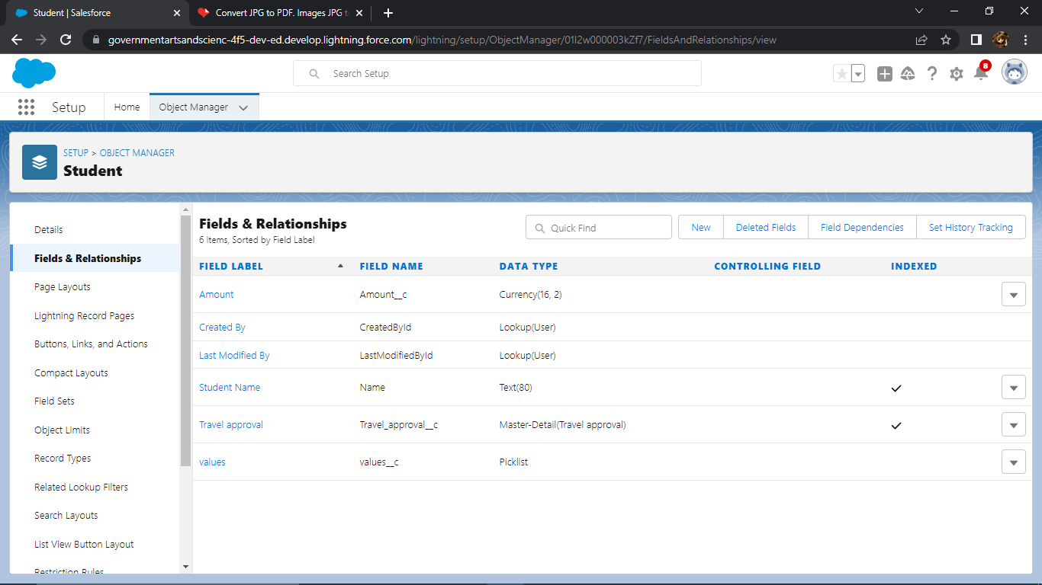

1. **Trailhead profile public URL**

**Team lead: Girija.R - https://trailblazer.me/id/pgirijar**

**Team members**

**1. Kaviya.A - http://trailblazer.me/id/kavi02**

**2. Narmatha.N - https://trailblazer.me/id/ptm-narmatha**

**3. Ranjini.v - http://trailblazer.me/id/ranjv13**

1. **Advantages & disadvantages**

**Advantages**

* Approvals on time. The entire process of planning and managing a trip is a long and stressful process. ...
* Customize approval workflows. The approval process can differ from company to company. ...
* Increase compliance and reduce costs. ...
* Faster process.
* Business travel is a great way to develop new skills and refine existing ones. From public speaking, adaptability, time management, networking, and best of all, confidence the knowledge and skills built with business travel are essential to a successful career.

**Disadvantages**

**Failing to partner with TMCs**

**Inefficient & inconsistent T& E management**

**Failing to adopt travel-based management technology**

1. **Application**

The Travel Support System (this is the name that you can see on the screen when executing the application) is a small sample application for NaturalONE. As a sample application, its focus is to show NaturalONE functionality rather than being a full-fledged travel support application.

The Travel Support System (TSS) allows you to request and approve business trips. Flights, hotels and even more external information such as cell phone expenses or car rentals can be entered with the trip request. For the destination, weather information can be queried. A manager can do both, request own trips as well as approve trips that have been requested by employees. After the manager has approved single or multiple requests, the manager can print an itinerary or receive the itinerary as a PDF file.

1. **Conclusion**

Here we've presented the look of a travel Approval Application on the Salesforce Platform which might provide the users with the specified travel assistant and also for the upper authorities to require care of the expenses at any point of your time through multilevel approvals of the travel request. Here the user can upload the bills to the cloud any time which is more efficient and productive. Travel Approval Application allows us to arrange and monitor travel plans and expense reports for our organization using Salesforce Platform. When it makes all the difference in closing and winning of any deal, this app provides you that perfect solution as a manager to timely approve the request and monitor travel plans and expenses for our organization, making them more efficient to use.

1. **Future scope**

* Apex developing tools.
* Using self-developed classes and triggers
* Using Flows and Screens
* Using visual force pages to develop proper HTML websites and custom HTML pages.
* Data analytics could even be implemented for smoother and prompt reports

**Thank you**